**President’s Malaria Initiative**

**Country Insecticide Susceptibility Summaries**

**June 2012**

Compiled by Dr. Christen Fornadel

[cfornadel@usaid.gov](mailto:cfornadel@usaid.gov)



**Introduction**

This report summarizes the insecticide susceptibility data that has been collected by the President’s Malaria Initiative (PMI) as of the end of June 2012. The report includes data collected by PMI entomologists and contractors, as well as data collected in collaboration with host-country universities or National Malaria Control Programs (NMCPs). In some cases data collected by other partners is also cited.

For each PMI country, background information on vector control interventions, particularly PMI-supported indoor residual spraying (IRS), is summarized. A note on the data collected and conclusions follow. Summary tables of mosquito mortality data are also included for each country.

Unless otherwise noted, WHO tube bioassays were conducted, and percent mortalities 24 hours after exposure were recorded for 2 to 5-day-old female mosquitoes reared from field-collected larvae. The numbers of mosquitoes tested are presented in parentheses.

WHO has revised their guidelines for the interpretation of WHO susceptibility data. Previously, WHO recommended that >98% mortality in tube bioassays indicated full susceptibility, that 80-97% susceptibility indicated probable resistance, and that <80% mortality indicated resistance to the insecticide being tested.[1] The revised guidelines state that if tests are conducted under ideal conditions (e.g., sample size of >100 mosquitoes, carried out at 25°C ± 2°C and 80% ± 10% relative humidity, replicated 2 or 3 times, and using fresh impregnated papers), then 98-100% mortality indicates susceptibility and <98% mortality indicates that further investigation is required to confirm resistance.[2]

For the purposes of this report, the old guidelines will be referenced since much of the data was collected before the new recommendation was put in place. Furthermore, in many instances sample sizes of >100 mosquitoes were not feasible and/or tests may have been conducted under less than ideal conditions. In the country data tables, green represents a susceptible population, yellow represents probable resistance, and red indicates a resistant population.

If data on resistance mechanisms was collected it is also included.

Much of the data presented here should be confirmed with additional testing, but overall this document provides valuable information regarding trends in insecticide resistance in PMI countries.

**ANGOLA**

PMI is the sole supporter of IRS in Angola. IRS support to Angola began in 2006. Currently, PMI-supported IRS occurs in 3 provinces: Huila (Round 7 in 2011), Huambo (Round 4 in 2011), and Cunene (Round 5 in 2011). Pyrethroids are the only insecticides that have been used since PMI began spraying. Pyrethroids will again be used in 2012.

**COMMENTS ON DATA:**

*An. coustani* and *An. gambiae* s.l. mosquitoes have been tested.

**CONCLUSIONS:**

* Recognizing the caveat that low numbers of mosquitoes have been tested, it appears that probable resistance to both pyrethroids and carbamates has developed in Angola in *An. coustani* and *An. gambiae* s.l.
* DDT and organophosphates have not been tested against *An. gambiae* s.l. by PMI to date

*An. gambiae* s.l.mosquitoes were tested unless otherwise noted.

|  |  |  |  |  |  |  |  |  |  |  |  |
| --- | --- | --- | --- | --- | --- | --- | --- | --- | --- | --- | --- |
|  | Deltamethrin .05 | | |  | Lambdacyhalothrin .05 | | | Bendiocarb .1 | | | |
|  | 2009 | 2010 | 2011 | 2012 | 2009 | 2010 | 2011 | 2009 | 2010 | 2011 | 2012 |
| Huambo | na | *100(59)\** | *92.2(30)\** | 93.8(16);*100(80)\** | *94(40)\** | na | na | na | *95(60)\** | *95.4(24)\** | *100(20)\** |
| Huila | na | *100(20)\** | 92 (15); *100(20)\** | 94.3 (35) | na | na | na | na | na | 88.5(30) | *100(40)\** |
| Cunene | na | na | 93.3(15) | 97.5 (80) | na | na | na | na | na | na | na |
|  |  |  |  |  |  |  |  |  |  |  |  |
| \**An. coustani* | |  |  |  |  | Fenitrothion | |  |  |  |  |
| 2011 IRS districts | |  |  |  |  | 2012 | |  |  |  |  |
|  |  |  |  |  | Huambo | *100 (60)\** | |  |  |  |  |
|  |  |  |  |  | Huila | na | |  |  |  |  |
|  |  |  |  |  | Cunene | na | |  |  |  |  |

**BENIN**

PMI is the sole supporter of IRS in Benin. PMI IRS support to Benin began in 2008. From 2008-2010, PMI-supported IRS occurred in Oueme region (4 districts). In 2011, IRS was discontinued in Oueme and initiated in Atacora region (7 districts). Four rounds of IRS with a carbamate were performed in Oueme before withdrawal, and a carbamate was used for the first round of spraying in 2011 in Atacora. A carbamate will again be used for IRS in Atacora in 2012.

**COMMENTS ON DATA:**

Susceptibility data were collected in collaboration with Centre de Recherche Entomologique de Contonou (CREC).

*An. gambiae* s.l. mosquitoes were tested. Frequencies for the kdr and Ace 1 mutations in Oueme post-IRS and in Atacora were determined in 2011.

**CONCLUSIONS:**

* *An. gambiae* s.l. in both Oueme and Atacora show a high prevalence of the kdr mutation, as well as phenotypic resistance to DDT and pyrethroids
* Probable resistance to carbamates is also being seen, particularly in Atacora where the Ace1 mutation is present
* Organophosphates have not been tested by PMI to date

|  |  |  |  |  |  |  |  |  |  |  |
| --- | --- | --- | --- | --- | --- | --- | --- | --- | --- | --- |
| **Atacora Region** | | | | | | | | | | |
| kdr mutation | Ace1 mutation |  | Deltamethrin .05% | | Permethrin .75% | | Bendiocarb .1 % | | DDT 4% | |
| 2010 | 2011 | 2010 | 2011 | 2010 | 2011 | 2010 | 2011 |
| 0.68 | 0.04 | Pehunco | 27(124) | na | 15(103) | na | 98(94) | na | na | na |
| 0.98 | 0.02 | Kouande | 31(147) | 87(90) | 6(108) | 62(76) | 95(126) | 89(82) | 14(63) | 26(90) |
| 0.98 | 0.02 | Colby | 37(68) | na | 0(47) | na | 98(42) | na | na | na |
| 0.69 | 0 | Boucoumbe | 31(67) | na | na | na | 95(56) | na | na | na |
| 0.85 | 0 | Materi | 31(147) | 91(65) | 6(108) | 45(96) | 95(83) | 87(85) | 12(65) | 27(97) |
| 0.71 | 0.02 | Tanguieta | 31(93) | 93(71) | 6(73) | 32(118) | 95(95) | 65(82) | 13(39) | 23(88) |
| 0.5 | 0.06 | Toukoutouna | 31(94) | na | 6(59) | na | 95(88) | na | 18(40) | na |
| 0.75 | 0.03 | Natintingou | 31(90) | 80(91) | 13(71) | 31(98) | 97(92) | 85(89) | 12(65) | 27(91) |
| 0.75 | 0.19 | Kerou | 51(72) | na | na | na | 96(89) | na | na | na |

|  |  |  |  |  |  |  |  |  |  |  |
| --- | --- | --- | --- | --- | --- | --- | --- | --- | --- | --- |
| **Oueme Region** | | | | | | | | | | |
| kdr mutation | Ace1 mutation |  | Deltamethrin .05% | | | | Permethrin .75% | | | |
|  | 2009 | 2010 | 2011 July | 2011 Dec | 2009 | 2010 | 2011 July | 2011 Dec |
| 0.8 | 0 | Adjohoun | 100(100) | 14(28) | 91(117) | 87(84) | 97.1(100) | 11(53) | 7 (88) | 75 (63) |
| 0.83 | 0 | Dangbo | 100(100) | 74(84) | 76(101) | 88(42) | 83.8(100) | 17(65) | 13(104) | 65(20) |
| 0.86 | 0 | Misserete | 100(100) | 70(54) | 93(89) | 97(112) | 90.8(100) | 16(62) | 27(94) | 66(93) |
| 0.86 | 0 | Seme | na | 85(99) | 92(88) | 80(81) | na | 14(99) | 33(83) | 85(48) |
|  |  |  |  |  |  |  |  |  |  |  |
|  |  |  | Bendiocarb .1% | | | | DDT 4% | | | |
|  |  |  | 2009 | 2010 | 2011 July | 2011 Dec | 2009 | 2010 | 2011 July | 2011 Dec |
|  |  | Adjohoun | 100(100) | 100(34) | 100 (84) | 90(89) | 64(100) | 0(35) | 6(82) | 5(19) |
|  |  | Dangbo | 100(100) | 100(45) | 100(112) | 100(40) | 45(100) | 2.5(48) | 1(98) | na |
|  |  | Misserete | 100(100) | 99(100) | 99(87) | 100(112) | 39(100) | 5(77) | 3(109) | 17(65) |
|  |  | Seme | na | 100(49) | 100(119) | 100(49) | na | 13(102) | 1(95) | 78(46) |
|  |  |  |  |  |  |  |  |  |  |  |
| IRS districts | |  |  |  |  |  |  |  |  |  |

**BURKINA FASO**

PMI is the sole supporter of IRS in Burkina Faso. PMI conducted IRS in Diebougou District in 2010 and 2011. In both years, carbamates were used. Additionally, 80% ITN coverage has been achieved in this district. In 2012 PMI will again spray Diebougou with a carbamate.

**COMMENTS ON DATA:**

Susceptibility data were collected in collaboration with Centre Muraz.

*An. gambiae* s.l. mosquitoes were tested. The numbers of mosquitoes tested were not reported.

Additionally, in 2010 the rate of the kdr mutation was estimated at 0.93 in *An. gambiae* s.s. (0.53 in the M form and 0.99 in the S form). The kdr mutation was absent in *An. arabiensis*.

**CONCLUSIONS:**

* In the three districts tested, *An. gambiae* s.l. shows resistance to pyrethroids and probable resistance to carbamates
* Regarding organophosphates, in Diebougou there appears to be full susceptibility to malathion, while there is probable resistance to fenitrothion in Dano
* DDT has not been tested by PMI to date

|  |  |  |  |  |  |  |  |  |
| --- | --- | --- | --- | --- | --- | --- | --- | --- |
|  | Deltamethrin .05% | | Bendiocarb .1% | | Malathion .5% | | Fenitrothion 1% | |
|  | 2010 | 2011 | 2010 | 2011 | 2010 | 2011 | 2010 | 2011 |
| Diebougou | 84 | 69 | 96 | 85 | 100 | ~100 | na | na |
| Dano | 95 | na | 82 | na | 99 | na | 92 | na |
| Gaoua | 45 | na | na | na | na | na | na | na |
|  |  |  |  |  |  |  |  |  |
| IRS district |  |  |  |  |  |  |  |  |

**ETHIOPIA**

PMI contributes to theGovernment of Ethiopia-led IRS operation, and has been supporting districts to varying degrees based on technical/financial capacity. PMI IRS support to Ethiopia began in 2008. PMI’s focus was originally Oromia Regional State, which, as the largest of Ethiopia’s nine states, comprises a third of the country’s territory and population; since 2011 support for IRS-related trainings and workshops, as well as entomological monitoring activities, has expanded to a national level. In 2008, PMI-supported IRS occurred in 19 districts in Oromia. By 2011 the number of PMI-supported districts increased to 50.

**COMMENTS ON DATA:**

Susceptibility data was collected by PMI in collaboration with Ethiopian universities.

*An. gambiae* s.l. mosquitoes were tested. Numbers of mosquitoes tested were not reported. Data referenced as Abate comes from Abate and Hadis 2011, *Trop Med Int Health*.

**CONCLUSIONS:**

* Insecticide susceptibility tests have been conducted in 25 districts in Oromia State
* There is widespread resistance to DDT and pyrethroids
* In 2010 there was full susceptibility to both bendiocarb and propoxur; in 2011 probable resistance to bendiocarb was seen in two districts
* As for organophosphates, there appears to be widespread resistance to malathion, but for the most part susceptibility to fenitrothion
* The four districts in Oromia tested for the organohosphate Actellic in 2009 showed full susceptibility

|  |  |  |  |  |  |  |  |  |  |  |  |  |  |  |  |  |  |  |  |
| --- | --- | --- | --- | --- | --- | --- | --- | --- | --- | --- | --- | --- | --- | --- | --- | --- | --- | --- | --- |
| **Regional State** | **District** | **Ref** | **Bendiocarb** | | | | | **Propoxur** | | | |  | **Deltamethrin** | | | | | | |
|  |  |  | **2007** | **2008** | **2009** | **2010** | **2011** | **2007** | **2008** | **2009** | **2010** | **2011** | **2005** | **2006** | **2007** | **2008** | **2009** | **2010** | **2011** |
| Oromia | Adama | PMI |  |  |  |  |  |  |  |  |  |  |  |  |  |  |  |  |  |
| Oromia | Adama | Balkew/PMI |  |  |  |  |  |  |  |  |  |  |  | 99.2 |  | 91 |  |  |  |
| Oromia | Lume | PMI |  |  |  |  |  |  |  |  |  |  |  |  |  |  |  |  |  |
| Oromia | Omo-Nada | PMI |  |  | 100 | 100 | 97.5 |  |  |  | 100 |  |  |  |  | 70 | 94 | 64 | 18.75 |
| Oromia | Merti | PMI |  |  | 99.1 |  |  |  |  |  |  |  |  |  |  |  | 76.2 |  |  |
| Oromia | Babile | PMI |  |  | 100 |  |  |  |  |  |  |  |  |  |  |  | 68.1 |  |  |
| Oromia | Adami Tulu | PMI |  |  | 96 |  |  |  |  |  | 100 |  |  |  |  | 26 | 46 |  |  |
| Oromia | Sibu Sire | PMI |  |  |  |  |  |  |  |  |  |  |  |  |  |  | 94.8 |  |  |
| Oromia | Bedele | PMI |  |  | 100 |  |  |  |  |  |  |  |  |  |  |  |  |  |  |
| Oromia | Chewaka | PMI |  |  |  |  | 100 |  |  |  |  |  |  |  |  |  |  |  | 21.59 |
| Oromia | Kersa | PMI |  |  | 100 |  |  |  |  |  |  |  |  |  |  |  | 78.8 |  |  |
| Oromia | Shashemene | PMI |  |  | 100 |  |  |  |  |  |  |  |  |  |  |  | 52 |  |  |
| Oromia | Mieso | PMI |  |  |  |  |  |  |  |  |  |  |  |  |  |  | 95 |  |  |
| Oromia | Bako Tibe | PMI |  |  | 100 |  |  |  |  |  |  |  |  |  |  |  |  |  |  |
| Oromia | Z Dugda | PMI |  |  |  | 100 | 80 |  |  |  | 100 |  |  |  |  |  |  | 96 | 21 |
| Oromia | Gololcha | PMI |  |  |  | 99 |  |  |  |  | 100 |  |  |  |  |  |  | 97 |  |
| Oromia | Gelana | PMI |  |  |  | 99 |  |  |  |  | 100 |  |  |  |  |  |  | 34 |  |
| Oromia | Hawi Gudina | PMI |  |  |  | 100 |  |  |  |  | 100 |  |  |  |  |  |  | 100 |  |
| Oromia | Mieso | PMI |  |  |  | 100 | 90 |  |  |  | 100 |  |  |  |  |  |  | 52 | 88 |
| Oromia | Shebe | PMI |  |  |  |  |  |  |  |  | 98.7 |  |  |  |  |  |  | 66.7 |  |
| Oromia | Gogu-Seyo | PMI |  |  |  | 100 |  |  |  |  | 100 |  |  |  |  |  |  |  |  |
| Oromia | Bedele | PMI |  |  |  | 100 |  |  |  |  | 100 |  |  |  |  |  |  | 100 |  |
| Oromia | Wondogonet | Abate |  |  |  |  |  |  |  |  |  |  |  |  | 97.4 |  |  |  |  |
| Oromia | Humbo | Abate |  |  |  |  |  |  |  |  |  |  |  |  |  | 94 |  |  |  |
| Oromia | Metehara | Abate |  |  |  |  |  |  |  |  |  |  | 100 |  |  |  |  |  |  |

|  |  |  |  |  |  |  |  |  |  |  |  |  |  |  |  |  |
| --- | --- | --- | --- | --- | --- | --- | --- | --- | --- | --- | --- | --- | --- | --- | --- | --- |
| **Regional State** | **District** | **Ref** | **Lambdacyhalotrhin** | | | | | |  | **DDT** | | | | | | |
|  |  |  | **2005** | **2006** | **2007** | **2008** | **2009** | **2010** | **2011** | **2005** | **2006** | **2007** | **2008** | **2009** | **2010** | **2011** |
| Oromia | Adama | PMI |  |  |  |  |  |  |  |  |  |  | 18 |  |  |  |
| Oromia | Adama | Balkew/PMI |  | 100 |  |  |  |  |  |  | 78.8 |  | 34.5 |  |  |  |
| Oromia | Lume | PMI |  |  |  |  |  |  |  |  |  |  | 10.8 |  |  |  |
| Oromia | Omo-Nada | PMI |  |  |  |  |  | 32 | 36.2 |  |  |  | 1 | 0 | 2 | 1.25 |
| Oromia | Merti | PMI |  |  |  |  |  |  |  |  |  |  |  | 13.3 |  |  |
| Oromia | Babile | PMI |  |  |  |  |  |  |  |  |  |  |  | 10.9 |  |  |
| Oromia | Adami Tulu | PMI |  |  |  |  |  |  |  |  |  |  | 1.2 | 0 | 5.6 |  |
| Oromia | Sibu Sire | PMI |  |  |  |  |  |  |  |  |  |  |  | 10.4 |  |  |
| Oromia | Bedele | PMI |  |  |  |  |  |  |  |  |  |  |  | 85 |  |  |
| Oromia | Chewaka | PMI |  |  |  |  |  |  |  |  |  |  |  |  |  | 2.17 |
| Oromia | Kersa | PMI |  |  |  |  |  |  |  |  |  |  |  | 3 |  |  |
| Oromia | Shashemene | PMI |  |  |  |  |  |  |  |  |  |  |  | 4.2 |  |  |
| Oromia | Mieso | PMI |  |  |  |  |  |  |  |  |  |  |  | 33.7 |  |  |
| Oromia | Bako Tibe | PMI |  |  |  |  |  |  |  |  |  |  |  | 35.1 |  |  |
| Oromia | Z Dugda | PMI |  |  |  |  |  | 45 | 3 |  |  |  |  |  | 11 | 2 |
| Oromia | Gololcha | PMI |  |  |  |  |  | 93 |  |  |  |  |  |  | 78.8 |  |
| Oromia | Gelana | PMI |  |  |  |  |  | 22.5 |  |  |  |  |  |  | 0 |  |
| Oromia | Hawi Gudina | PMI |  |  |  |  |  | 94 |  |  |  |  |  |  | 19 |  |
| Oromia | Mieso | PMI |  |  |  |  |  | 81 | 82 |  |  |  |  |  | 44 | 11 |
| Oromia | Shebe | PMI |  |  |  |  |  |  |  |  |  |  |  |  | 14.7 |  |
| Oromia | Gogu-Seyo | PMI |  |  |  |  |  | 82 |  |  |  |  |  |  |  |  |
| Oromia | Bedele | PMI |  |  |  |  |  | 94 |  |  |  |  |  |  | 17 |  |
| Oromia | Wondogonet | Abate |  |  | 17.5 |  |  |  |  |  |  | 12.2 |  |  |  |  |
| Oromia | Humbo | Abate |  |  |  | 46.1 |  |  |  |  |  |  | 4 |  |  |  |
| Oromia | Metehara | Abate | 100 |  |  |  |  |  |  | 86 |  |  |  |  |  |  |

|  |  |  |  |  |  |  |  |  |  |  |  |  |  |  |  |  |  |  |  |
| --- | --- | --- | --- | --- | --- | --- | --- | --- | --- | --- | --- | --- | --- | --- | --- | --- | --- | --- | --- |
| **Regional State** | **District** | **Ref** | **Malathion** | | | | | | | **Fenitrothion** | | | | | **Actellic** | | | | |
|  |  |  | **2005** | **2006** | **2007** | **2008** | **2009** | **2010** | **2011** | **2007** | **2008** | **2009** | **2010** | **2011** | **2007** | **2008** | **2009** | **2010** | **2011** |
| Oromia | Adama | PMI |  |  |  |  |  |  |  |  |  |  |  |  |  |  |  |  |  |
| Oromia | Adama | Balkew/PMI |  |  |  |  |  |  |  |  |  |  |  |  |  |  | 100 |  |  |
| Oromia | Lume | PMI |  |  |  |  |  |  |  |  |  |  |  |  |  |  |  |  |  |
| Oromia | Omo-Nada | PMI |  |  |  | 91.2 | 81 | 100 | 72.5 |  |  |  | 100 | 68 |  |  | 100 |  |  |
| Oromia | Merti | PMI |  |  |  |  | 96.8 |  |  |  |  |  |  |  |  |  |  |  |  |
| Oromia | Babile | PMI |  |  |  |  | 100 |  |  |  |  |  |  |  |  |  |  |  |  |
| Oromia | Adami Tulu | PMI |  |  |  | 93.7 | 92 |  |  |  |  |  |  |  |  |  |  |  |  |
| Oromia | Sibu Sire | PMI |  |  |  |  | 92.5 |  |  |  |  |  |  |  |  |  |  |  |  |
| Oromia | Bedele | PMI |  |  |  |  |  |  |  |  |  |  |  |  |  |  |  |  |  |
| Oromia | Chewaka | PMI |  |  |  |  |  |  | 80.9 |  |  |  |  | 97.71 |  |  |  |  |  |
| Oromia | Kersa | PMI |  |  |  |  | 73 |  |  |  |  |  |  |  |  |  | 100 |  |  |
| Oromia | Shashemene | PMI |  |  |  |  |  |  |  |  |  |  |  |  |  |  |  |  |  |
| Oromia | Mieso | PMI |  |  |  |  |  | 100 |  |  |  |  |  |  |  |  |  |  |  |
| Oromia | Bako Tibe | PMI |  |  |  |  |  |  |  |  |  |  |  |  |  |  | 100 |  |  |
| Oromia | Z Dugda | PMI |  |  |  |  |  | 94.1 | 66 |  |  |  | 99 | 100 |  |  |  |  |  |
| Oromia | Gololcha | PMI |  |  |  |  |  | 99 |  |  |  |  | 97 |  |  |  |  |  |  |
| Oromia | Gelana | PMI |  |  |  |  |  | 94.3 |  |  |  |  | 97.3 |  |  |  |  |  |  |
| Oromia | Hawi Gudina | PMI |  |  |  |  |  | 100 |  |  |  |  | 100 |  |  |  |  |  |  |
| Oromia | Mieso | PMI |  |  |  |  | 100 |  |  |  |  |  | 100 | 100 |  |  |  |  |  |
| Oromia | Shebe | PMI |  |  |  |  |  | 80 |  |  |  |  | 100 |  |  |  |  |  |  |
| Oromia | Gogu-Seyo | PMI |  |  |  |  |  |  |  |  |  |  |  |  |  |  |  |  |  |
| Oromia | Bedele | PMI |  |  |  |  |  | 95 |  |  |  |  | 100 |  |  |  |  |  |  |
| Oromia | Wondogonet | Abate |  |  | 94.4 |  |  |  |  |  |  |  |  |  |  |  |  |  |  |
| Oromia | Humbo | Abate |  |  |  | 99 |  |  |  |  |  |  |  |  |  |  |  |  |  |
| Oromia | Metehara | Abate | 100 |  |  |  |  |  |  |  |  |  |  |  |  |  |  |  |  |

**GHANA**

Ghana began implementing IRS with the support of PMI in 2008, by spraying five northern region districts (Tolon/Kumbungu, Savelugu/Nanton, West Mamprusi, Gushegu, and Karaga). The number of beneficiary districts was steadily scaled up to 9 by adding four new districts (East Mamprusi, Saboba, Chereponi, and Bunkrurugu-Yunyoo) by the close of 2011. From 2008 to 2011 pyrethroids were used for IRS. In 2012 pyrethroids and organophosphates will be used for PMI-supported IRS. In addition, with Global Fund support, the Government of Ghana will expand its IRS program to 70 districts (virtually nationwide).

**COMMENTS ON DATA:**

### Susceptibility data was collected in collaboration with Noguchi Memorial Institute for Medical Research.

*An. gambiae* s.l. mosquitoes were tested. Of the 9 districts where IRS occurred in 2011, WHO susceptibility tests were conducted in 3, with the data from Tolon and Savelugu pooled. For 2011 data, 3 test replicates, for a total of 60 mosquitoes, were tested for each insecticide.

Additionally, in 2011 kdr frequencies were evaluated:

|  |  |  |  |  |
| --- | --- | --- | --- | --- |
|  | ***Frequency of kdr gene*** | | | |
|  | **RR** | **RS** | **SS** | **TOTAL** |
| **Study area** | **No. (%)** | **No. (%)** | **No. (%)** | **No.** |
| **Tolon** | 25 **(78.1)** | 0 **(0)** | 7 **(21.9)** | 32 |
| **Savelugu** | 27 **(90.0)** | 0 **(0)** | 2 **(6.6)** | 30 |
| **Tamale** | 19 **(65.5)** | 0 **(0)** | 10 **(34.5)** | 29 |

**CONCLUSIONS:**

* In Tolon and Savelugu *An. gambiae* s.l. shows resistance to DDT and probable resistance to pyrethroids; susceptibility remains fairly high toward both carbamates and organophosphates, although there are some indications that resistance might be emerging
* In Bunkrurugu-Yunyoo *An. gambiae* s.l. is completely susceptible to carbamates; susceptibility remains fairly high toward pyrethroids, although there are some indications that resistance might be emerging ; DDT and organophosphates have not been tested by PMI to date in Bunkrurugu-Yunyoo

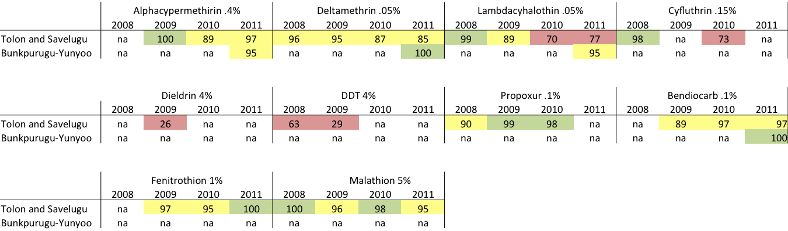

**KENYA**

Through 2010, the Kenya Division of Malaria Control supported focal IRS in 16 epidemic prone highland districts. In 2008 and 2009, PMI provided additional support for the highland districts, Nandi North and Nandi South, and support to spray the endemic district, Rachuonyo, along the shores of Lake Victoria. Beginning in 2010, PMI support for IRS was targeted at three endemic districts: Rachuonyo, Nyando, and Migori.[3] The same districts were targeted in 2011. From 2008-2011, PMI-supported IRS was conducted using pyrethroids. In 2012, pyrethroids will again be used.

**COMMENTS ON DATA:**

Susceptibility data was collected in collaboration with Kenya Medical Research Institute (KEMRI) and in conjunction with Kenya’s Division of Malaria Control (DOMC) and their WHO/Insecticide Resistance project.

2008 - CDC bottle bioassays were used to test lambda-cyhalothrin and malathion on mosquitoes collected from 3 sites in Nyando District and 3 sites in Rachuonyo District. An. arabiensis was fully susceptible to lambda-cyhalothrin and malathion.

2009, 2010, & 2011 – WHO tube bioassays were used for resistance testing. No susceptibility testing has been done in the PMI IRS district of Migori.

**CONCLUSIONS:**

* Probable pyrethroid resistance has developed within the *An. arabiensis* population in IRS areas
* *An. arabiensis* appears to be susceptible to carbamates in the IRS district of Nyando
* *An. gambiae* s.s. in Bungoma and Busia shows high levels of pyrethroid resistance and probable carbamate resistance
* *An. gambiae* s.l. from all sites tested showed at least probable resistance to pyrethroids, with some areas demonstrating high resistance levels; differences may correspond to varying ratios of *An. arabiensis* and *An. gambiae* s.s. in each area
* In limited testing, all mosquitoes were susceptible to malathion

|  |  |  |  |  |  |  |  |  |  |  |  |  |  |
| --- | --- | --- | --- | --- | --- | --- | --- | --- | --- | --- | --- | --- | --- |
| **Species** | **Location** | **DDT** | | **Permethrin** | | **Deltamethrin** | | **Alpha-cypermethrin** | **Lambda-cyhalothrin** | **Bendiocarb** | | **Malathion** | |
|  |  | **2009/2010** | **2011** | **2009/2010** | **2011** | **2009/2010** | **2011** | **2011** | **2011** | **2009/2010** | **2011** | **2009/2010** | **2011** |
| *A. gambiae.* s.l. | Bungoma | 78 (54) | na | 84 (148) | na | 89 (88) | na | na | na | na | na | na | na |
|  | Busia | 21 (78) | na | 54 (347) | na | 78 (249) | na | na | na | na | na | na | na |
|  | Kakamega | 78 (188) | na | 85 (225) | na | 87 (342) | na | na | na | na | na | na | na |
|  | Kisumu W. | na | na | 84 (231) | na | 91 (22) | na | na | na | na | na | na | na |
|  | Teso | 64 (59) | na | 68 (627) | na | 89 (774) | na | na | na | na | na | na | na |
|  | Nyando | na | na | 91 | 96 (280) | 91 | 96 (530) | na | 98 (99) | 97 | na | na | na |
|  | Rachuonyo | na | na | na | 77 (321) | na | 84 (303) | 82 (222) | 68 (278) | na | na | na | na |
|  | Rarieda | na | na | na | 60 (920) | na | 78 (787) | 66 (684) | 41 (763) | na | na | na | na |
|  |  |  |  |  |  |  |  |  |  |  |  |  |  |
| *A. gambiae.* s.s. | Bungoma | 62 (37) | na | 74 (74) | 28 (104) | 42 (19) | 63 (104) | na | na | 96 (25) | 83 (99) | 100 (44) | na |
|  | Busia | 33 (15) | na | 16 (25) | na | 48 (21) | na | na | na | 79 (19) | na | 100 (15) | na |
|  |  |  |  |  |  |  |  |  |  |  |  |  |  |
| *A. arabiensis* | Rarieda | 100 (36) | na | 97 (64) | na | 83 (29) | na | na | na | 100 (34) | na | 100 (24) | na |
|  | Budalangi | 100 (23) | na | 100 (21) | 78 (88) | 100 (25) | 86 (79) | na | na | 94 (17) | 98 (61) | 100 (32) | na |
|  | Busia | 98 (42) | na | 87 (23) | na | 100 (18) | na | na | na | 93 (15) | na | 100 (18) | na |
|  | Kakamega | 100 (8) | na | 82 (11) | na | 100 (15) | na | na | na | 82 (11) | na | 100 (10) | na |
|  | Kisian | 100 (32) | na | 87 (63) | na | 94 (70) | na | na | na | 100 (24) | na | 100 (16) | na |
|  | Nyando | na | na | na | 92 (137) | na | 92 (130) | na | na | na | 98 (160) | na | na |
|  | Rachuounyo | na | na | na | 86 (102) | na | 85 (102) | na | na | na | na | na | na |
|  |  |  |  |  |  |  |  |  |  |  |  |  |  |
| IRS districts |  |  |  |  |  |  |  |  |  |  |  |  |  |

**LIBERIA**

Liberia has been conducting PMI-supported IRS since 2009. PMI is the main supporter of IRS. In collaboration with PMI, three small, private firms have contributed modestly to IRS in their catchment areas. In 2009, IRS with pyrethroids occurred in three districts in Grand Bassa and Margibi counties. In 2010, pyrethroids were sprayed in 8 districts in Grand Bassa, Margibi, and Montserrado. In 2011, IRS expanded to 14 districts in 5 counties including the new counties of Bong and Nimba. Pyrethroids were used in all districts except those in Bong and Montserrado, which used carbamates and the latter were sprayed twice during the year. In 2012 a combination of pyrethroids and carbamates will again be sprayed.

**COMMENTS ON DATA:**

WHO bioassays were conducted on *Anopheles* spp. mosquitoes reared from field-field collected larvae. Only 2010 data specified that the mosquitoes used were *An. gambiae* s.l.

**CONCLUSIONS:**

* Taking into consideration the low numbers of mosquitoes tested, probable resistance to pyrethroids is likely in all 5 IRS counties
* 2011 data show that there appears to be full susceptibility to organophosphates, and there was full susceptibility to DDT when tests were last conducted in 2009 in Grand Bassa, Margibi, and Montserrado
* While there is full susceptibility to carbamates in Margibi, Montserrado , and Nimba, there is probable resistance to carbamates being seen in Grand Bassa and Bong

|  |  |  |  |  |  |  |  |  |  |  |  |  |  |  |  |
| --- | --- | --- | --- | --- | --- | --- | --- | --- | --- | --- | --- | --- | --- | --- | --- |
|  | Deltamethrin .05% | | | Lambda-cyhalothrin | | | Bendiocarb .1% | | | DDT 4% | | | Fenitrotion | | |
| Counties | 2009 | 2010 | 2011 | 2009 | 2010 | 2011 | 2009 | 2010 | 2011 | 2009 | 2010 | 2011 | 2009 | 2010 | 2011 |
| Bong | na | 87 (86) | na | na | na | 82 (65) | na | 100 (47) | 85 (60) | na | na | na | na | na | 100 (19) |
| Grand Bassa | 100 (40) | 98 (72) | na | na | na | 90 (40) | 100 (38) | 100 (25) | 95 (41) | 98 (58) | na | na | na | na | 98 (41) |
| Margibi | 98 (41) | 94 (79) | na | na | na | 93 (87) | 100 (20) | 92 (54) | 100 (60) | 100 (37) | na | na | na | na | 100 (45) |
| Montserrado | 100 (38) | 82 (49) | na | na | na | 87 (88) | 100 (39) | 100 (48) | 99 (85) | 98 (42) | na | na | na | na | 100 (96) |
| Nimba | na | 100 (24) | na | na | na | 89 (41) | na | 100 (21) | 100 (40) | na | na | na | na | na | na |
|  |  |  |  |  |  |  |  |  |  |  |  |  |  |  |  |
| IRS counties |  |  |  |  |  |  |  |  |  |  |  |  |  |  |  |

**MADAGASCAR**

|  |  |  |
| --- | --- | --- |
| **Round** | **Targeted Districts** | **Insecticide** |
| Round 1 (2008) & Round 2 (2009) | •  **Central Highlands and Fringe:** Anjozorobe, Ankazobe, Betafo/Mandoto, Ambositra, Ambatofinandrahana, and Ambohimahasoa | Pyrethroid |
| Round 3 (2010) | • **Central Highlands and Fringe:** Anjozorobe (Carb), Ankazobe (PY), Betafo/Mandoto (Carb), Ambositra (PY), Ambatofinandrahana (Carb), and Ambohimahasoa (PY) | Pyrethroid in CHLs) & Carbamate in Fringe, South, and Northwest |
| •**South:** Betroka, Bekily, Ampanihy, Beloha, Tsihombe, Ambovombe, and Amboasary; 5 communes in Tolagnaro |
| • **Northwest:** Maevatanana, Kandreho, and Tsaratanana |
| Round 4 (2011) | • **Central Highlands and Fringe:** Anjozorobe (Carb), Ankazobe (PY), Betafo/Mandoto (Carb), Ambositra (PY), Ambatofinandrahana (Carb), and Ambohimahasoa (PY) | Pyrethroid in CHLs) & Carbamate in Fringe and South |
| •**South:** Betroka, Bekily, Ampanihy, Beloha, Tsihombe, Ambovombe, and Amboasary; 5 communes in Tolagnaro |

PMI began implementing the IRS program in Madagascar in 2008 with seven districts and scaled up to 18 districts in 2010. Since 2010, the Madagascar NMCP has added an additional 21 districts to its IRS program. In 2011, PMI supported spraying in 15 districts. For districts sprayed and insecticides used see the table below. Decisions on which insecticides to spray in 2012 have not been made yet.

**COMMENTS ON DATA:**

Resistance monitoring in Madagascar is carried out by the National Malaria Control Program (PNLP), the WHO/Gates Foundation Project (UGP), the Institute Pasteur Madagascar (IPM), and PMI.

2006-09 – Details of how the assays were performed are unknown.

2010/11 – WHO bioassays were performed on 2 to 4-day-old females obtained as field collected larvae, F1 progeny of wild caught adults, or wild adult mosquitoes. In some instances CDC bottle bioassays were used.

**CONCLUSIONS:**

* For *An. gambiae* s.l. in PMI IRS areas, there is probable resistance to DDT
* There is evidence of probable pyrethroid and carbamate resistance in *An. gambiae* s.l. at several sites; there is also evidence that pyrethroid resistance may be emerging in *An. funestus* in Tsaratanana
* There is full susceptibility to organophosphates

|  |  |  |  |  |  |  |  |  |  |  |  |  |
| --- | --- | --- | --- | --- | --- | --- | --- | --- | --- | --- | --- | --- |
| ***An. gambiae* s.l.** |  |  |  |  |  |  |  |  |  |  |  |  |
|  | Deltamethrin | | Lambdacyhalothrin | | Permethrin | | Bendiocarb | | DDT | | Fenitrothion | |
|  | 2006-09 | 2010/11 | 2006-09 | 2010/11 | 2006-09 | 2010/11 | 2006-09 | 2010/11 | 2006-09 | 2010/11 | 2006-09 | 2010/11 |
| Amboasary | na | 100 | na | 95 (100) CDC* | na | 92 (100) CDC* | na | 99 (100) | na | 92 (100) | na | 100 (102) |
| Tsaratanana | na | 100 (100) | na | 91 (100) | na | 100 (100) | na | 100 (100) | na | 99 (100) | na | 98 (100) |
| Betafo | na | 100 (100) | *100 (100)#* | 100 (99) | na | 98 (104) | na | 99 (100) | na | 92 (97) | na | 98 (103) |
| Ankazobe | 88 (101) | 100 (60) | na | 100 (60) | 73 (67) | 100 (58) | 100 (30) | 96 (100) CDC* | 91(99) | 97 (68) | *100 (91)^* | 100 (57) |
| Antananarivo | 91 (200) | na | 90.5 (225) | na | 100 (97) | na | 84 (200) | na | 73 (100) | na | *100 (98)^* | na |
| Anjozorobe | 100 (106) | na | na | na | na | na | na | na | 100 (62) | na | *100 (111)^* | na |
| Ambato/Hana | 99 (121) | na | na | na | 93 (149) | na | 90 (120) | na | 89 (122) | na | *100 (120)^* | na |
| Fianar II | 92 (104) | na | na | na | 63 (101) | na | na | na | 72 (106) | na | *100 (103)^* | na |
| Betioky Sud | 100 (96) | na | na | na | na | na | na | na | 97 (73) | na | na | na |
| Manakara | 71 (103) | na | na | na | na | na | na | na | 65 (100) | na | na | na |
| Mampikony | na | na | na | na | na | na | na | na | 100 (70) | na | na | na |
| Ambato-boeni | na | na | na | na | na | na | na | na | 100 (106) | na | na | na |
| Atsimondrano | na | na | na | 97 (100) | na | na | na | na | na | na | na | na |
| Soavinandriana | na | na | na | 96 (100) | na | na | na | na | na | na | na | na |
| Brickaville | na | na | na | na | na | 82 (100) | na | 94 (100) | na | na | na | na |
| Manandriana | na | na | na | na | na | 95 (100) | na | na | na | na | na | na |
| Morondava | na | na | na | 53 (100) | na | na | na | na | na | na | na | na |
| Boriziny | na | 75 (100) | na | 80 (100) | na | 68 (100) | na | na | na | na | na | na |
| Brieville | na | na | na | 92 (100) CDC* | na | na | na | na | na | na | na | na |
| Ambatofinandrahana | na | na | na | 97 (100) CDC* | na | na | na | na | na | na | na | na |
| *# Test used Alphacypermethrin* | | | *^Test used Malathion* | | |  |  |  |  |  |  |  |
| *Indicates CDC bottle assay; for CDC assays lambdacyhalothrin, permethrin, and deltamethrin tests conducted with 12.5ug of insecticide/bottle | | | | | | | | | | | | |
|  |  |  |  |  |  |  |  |  |  |  |  |  |
| ***An. funestus*** |  |  |  |  |  |  |  |  |  |  |  |  |
|  | Deltamethrin | | Lambdacyhalothrin | | Permethrin | | Bendiocarb | | DDT | | Fenitrothion | |
|  | 2006-09 | 2010/11 | 2006-09 | 2010/11 | 2006-09 | 2010/11 | 2006-09 | 2010/11 | 2006-09 | 2010/11 | 2006-09 | 2010/11 |
| Anjozorobe | na | na | na | na | na | na | na | na | 98 (111) | na | na | na |
| Ankazobe | na | na | na | na | na | na | 100 (48) | na | na | na | na | na |
| Tsaratanana | na | na | na | 97 (100) | na | na | na | na | na | na | na | na |
| Brieville | na | na | na | 97 (73) | na | na | na | na | na | na | na | na |
|  |  |  |  |  |  |  |  |  |  |  |  |  |
| 2011 PMI IRS districts | |  |  |  |  |  |  |  |  |  |  |  |

**MALAWI**

From 2007 to 2009, IRS was conducted by PMI in Nkhotakota District with pyrethroids. In 2010 and 2011, IRS was scaled up to an additional six districts (Karonga, Nkhata Bay, Salima, Mangochi, Chikwawa, and Nsanje). IRS in Nkhotakota and Salima is funded by PMI, while IRS in the remaining districts is funded by the Malawi government. In 2010 and 2011 the Government of Malawi-funded districts were sprayed with a pyrethroid, while the two PMI districts were sprayed with an organophosphate (pirimiphos-methyl, Actellic EC) in 2010. In 2011 PMI only sprayed Nkhotakota, again with Actellic EC. IRS will not be conducted in Malawi in 2012.

**COMMENTS ON DATA:**

Susceptibility data was collected in collaboration with the Malaria Alert Center (MAC). 2010/11 data was collected between February 2010 and November 2011. F1 progeny of wild caught adults were used for testing. Some *An. funestus* data has been pulled from Hunt et al. 2010, *Parasit Vectors*.

**CONCLUSIONS:**

* *An. funestus* in Malawi shows strong resistance to both pyrethroids and carbamates and probable resistance to DDT, but susceptibility to organophosphates
* *An. gambiae* s.l. is showing probable resistance in some districts to both pyrethroids and carbamates, but complete susceptibility to organophosphates

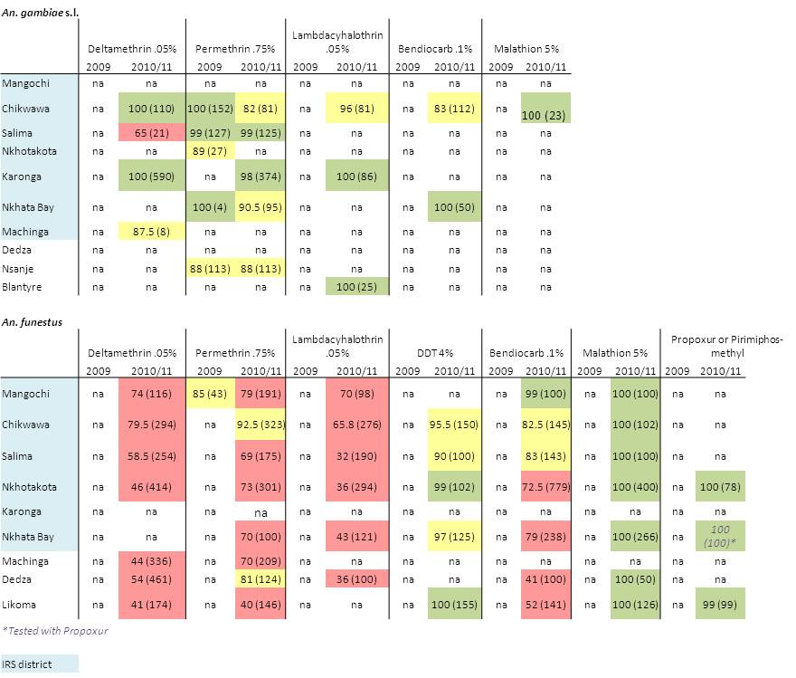

**MALI**

PMI is the sole supporter of IRS in Mali. From 2008 to 2010, IRS was conducted with a pyrethroid in Bla and Koulikoro. In 2011, IRS was conducted in Bla, Koulikoro, and Baroueli with a carbamate. In 2012 a carbamate will again be used.

**COMMENTS ON DATA:**

Susceptibility data was collected in collaboration with Malaria Research & Training Center (MRTC), University of Bamako.

Results presented are for *An. gambiae* s.l. For 2009 data, mosquitoes reared from field-collected larvae were used, while F1 mosquitoes were used in 2010.

Additionally, in 2009, 417 mosquitoes were sampled for the kdr mutation from the different locations tested for insecticide resistance that year. No samples were positive for the mutation.

**CONCLUSIONS:**

* In the IRS districts, *An. gambiae* s.l. is resistant to pyrethroids and DDT, but susceptible to carbamates; no tests with organophosphates have been conducted in IRS districts
* Similarly, for the non-IRS districts tested in 2009, pyrethroid and DDT resistance has been seen, but there is susceptibility to carbamates and organophosphates

|  |  |  |  |  |  |  |  |  |  |  |  |  |
| --- | --- | --- | --- | --- | --- | --- | --- | --- | --- | --- | --- | --- |
|  |  |  |  |  | Lambda-cyhalothrin .05% | |  |  |  |  |  |  |
|  | Deltamethrin .05% | | Permethrin .75% | | DDT 4% | | Bendiocarb .1% | | Fenitrothion | |
|  | 2009 | 2010 | 2009 | 2010 | 2009 | 2010 | 2009 | 2010 | 2009 | 2010 | 2009 | 2010 |
| Koulikoro | na | 50 (300) | na | na | na | 82 (200) | na | 40 (100) | na | 98 (200) | na | na |
| Bla | na | 68.5 (400) | na | na | na | 68 (100) | na | na | na | 97 (200) | na | na |
| Baraoueli | na | 61 (300) | na | 79 (300) | na | 56 (300) | na | 62 (300) | na | 100 (300) | na | na |
| Bamako | 80 (100) | na | 75 (100) | na | 80 (100) | na | 56 (100) | na | 97 (100) | na | 100 (100) | na |
| Kati | 97 (200) | na | 68 (200) | na | 76.5 (200) | na | 81.5 (200) | na | 100 (200) | na | 100 (200) | na |
| Gao | 94 (100) | na | 69 (100) | na | 74 (100) | na | 95 (100) | na | 100 (100) | na | 100 (100) | na |
| Niono | 91 (200) | na | 97 (200) | na | 89.5 (200) | na | 89.5 (200) | na | 100 (200) | na | 100 (200) | na |
| Badiangara | 72.5 (200) | na | 79.5 (200) | na | 66.5 (200) | na | 76 (200) | na | 100 (200) | na | 100 (200) | na |
| Bougouni | 98 (200) | na | 98.5 (200) | na | 87.5 (200) | na | 70.5 (200) | na | 100 (200) | na | 99 (200) | na |
| Kita | 88 (200) | na | 98 (200) | na | 85 (200) | na | 95 (200) | na | 97.5 (200) | na | 98.5 (200) | na |
| Djenné | 91 (100) | na | 100 (100) | na | 94 (100) | na | 100 (100) | na | 99 (100) | na | 98 (100) | na |
| Tombouctou | 97 (100) | na | 98 (100) | na | 100 (100) | na | 52 (100) | na | 100 (100) | na | 100 (100) | na |
|  |  |  |  |  |  |  |  |  |  |  |  |  |
| IRS districts |  |  |  |  |  |  |  |  |  |  |  |  |

**MOZAMBIQUE**

In 2005, the NMCP resumed IRS in Zambezia in three districts, using DDT. Restricted expansion of IRS occurred in 2006 to cover five districts, and this effort was strengthened in 2007 by PMI. IRS was focused on densely populated areas using DDT or lambdacyhalothrin. In 2009, pyrethroids were the sole class of insecticides purchased for IRS, although all remaining stocks of DDT were sprayed during that year. Pyrethroids were sprayed in 2010 and 2011. 2011 IRS targeted areas included 8 districts in Zambezia Province – Quelimane (Round 5), Nicoadala (R5), Namacurra (R5), Mocuba (R5), Morrumbala (R5), Milange (R5), Maganja da Costa (R2) and Mopeia (R2). A pyrethroid will again be sprayed in 2012.

**COMMENTS ON DATA:**

**All districts evaluated are in Zambezia Province[4]**

2007-2008 collections: Mosquitoes tested were field-collected adults. Of 2011 targeted districts, 6 unique villages were evaluated. One was tested using *An. gambiae* s.l. (Maganja da Costa) and 6 used *An. funestus* (Maganja da Costa, Mocuba, Morrumbala, Namacurra, Nicoadala, and Quelimane)

2009/10 collections: Blood fed females were collected in the field and induced to lay eggs. Testing was done on F1 offspring. Data were collected from three 3 unique districts. Two districts were evaluated for *An. gambiae* s.l.(Muibi & Mocuba). For *An. funestus*, the districts evaluated were Mugeba & Milange.

2010 collections: *An. gambiae* s.l. reared from field-collected larvae were used. Data were collected from three 3 unique districts. However, of the 2011-targeted districts, only 2 were evaluated (Maganja da Costa & Mopeia). The other district evaluated was Pebane.

2011 collections: *An. gambiae* s.l.reared from field-collected larvae were used. Data were collected from 2 districts, both of which were 2011 target districts (Maganja da Costa & Mocuba).

2012 collections: *An. gambiae* s.l. and *An. funestus* reared from field-collected larvae were tested. Mosquitoes were tested from 3 IRS sites (Mocuba, Morrumbala, and Nicoadala).

**CONCLUSIONS:**

* While the low number of mosquitoes routinely being tested is a concern, the general insecticide resistance trends indicate susceptibility for *An. gambiae* s.l. to all classes of insecticide.
* *An. funestus* appears susceptible to DTT, deltamethrin, and permethrin but is beginning to show low to moderate levels of resistance toward lambdacyhalothrin and bendiocarb

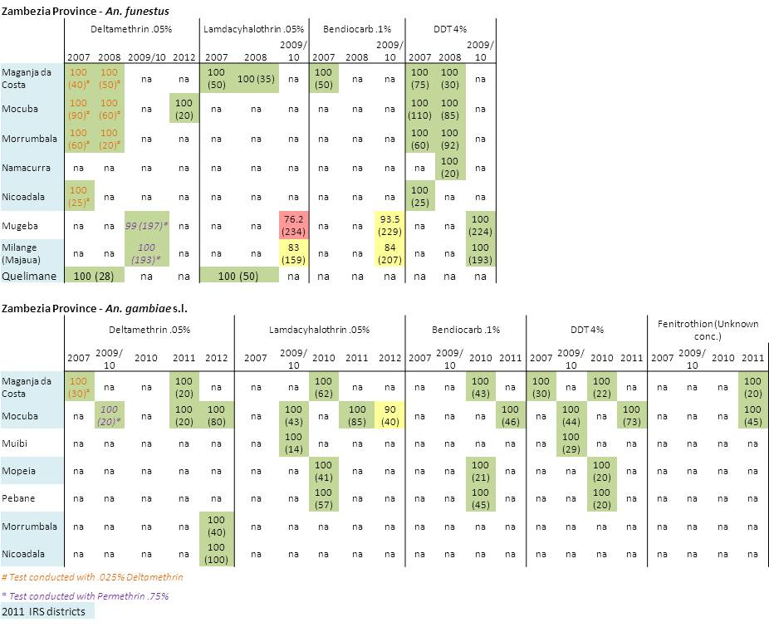

**NIGERIA**

The first round of PMI-supported IRS will occur in 2012 in Nasarawa Eggon and Doma LGAs in Nasarawa state. PMI is the only supporter of IRS in Nigeria.

**COMMENTS ON DATA:**

Susceptibility data was collected in collaboration with the University of Jos.

CDC bottle assays were used for *An. gambiae* s.l. susceptiblity testing in 2011. Tests were performed on field-collected larvae from Nasarawa Eggon. Four replicates and one control were run for each insecticide with 25 mosquitoes per bottle. The diagnostic time between susceptibity and resistance is 30 minutes for pyrethroids, organophosphates, and carbamates, while DDT is 45 minutes. Below is a table showing time unti complete knockdown for 10 different insecticides.

|  |  |  |
| --- | --- | --- |
| **Insecticide** | **Class of Chemical** | **Complete knockdown Time (Minutes)** |
| Bendiocarb 12.5 ug/bottle | Carbamates | 5 |
| Lambdacyhalothrin 12.5 ug/bottle | Pyrethroids | 12 |
| Malathion 50 ug/bottle | Organophosphates | 13 |
| Alpha-cypermethrin 12.5 ug/bottle | Pyrethroids | 15 |
| Fenitrothion 50 ug/bottle | Organophosphates | 20 |
| Deltamethrin 12.5 ug/bottle | Pyrethroids | 30 |
| Permethrin 21.5 ug/bottle | Pyrethroids | 30 |
| Pirimiphos-methyl 20 ug/bottle | Organophosphates | 51 |
| DDT 100 ug/bottle | Organochlorides | 120 |
| ETAA 12.5 ug/bottle |  | >120 |

**CONCLUSIONS:**

* *An. gambiae* s.l. in Nasarawa Eggon are susceptible to the pyrethroids deltamethrin, alpha-cypermethrin, lamdacyhalothin, and permethrin
* In addition, the mosquitoes tested were susceptible to bendiocarb, malathion, and fenitrothion
* However, the mosquitoes tested were resistant to DDT, ETAA, and pirimiphos-methyl

**RWANDA**

PMI is the sole supporter of seasonal IRS in Rwanda, although the Government of Rwanda has, on occasion, supported IRS for epidemics. The PMI IRS program in Rwanda was launched in 2007, with three districts (Gasabo, Nyarugenge, and Kicukiro) in Kigali Province that were blanket sprayed. In 2008 the same districts were sprayed plus the two districts of Kirehe and Nyanza. However, focal spraying was used, targeting high malaria burden sectors. An additional spray round was conducted in Jan-Feb 2009 to cover Rwanda’s eight month transmission season. In 2009 the districts of Bugasera and Nyagatere were added for a total of 7 districts. In 2011 IRS was withdraw from Kigali based on epidemiological and entomological data so spraying shifted to a new district - Gisagara, and continued in Bugesera, Kirehe, Nyanza, and Nyagatare districts. Blanket spraying was conducted.

Pyrethroids have been sprayed in all years and will be sprayed in 2012.

**COMMENTS ON DATA:**

Susceptibility data was collected in collaboration with the National Malaria Control Program.

*An. gambiae* s.l. larvae were collected from field sites and reared to adults for testing. No susceptibility tests have been done in the new 2011 IRS district of Gisagara.

**CONCLUSIONS:**

* *An. gambiae* s.l in Kigali and Nyagatare show resistance to DDT
* Some probable resistance is starting to be seen against pyrethroids (notably deltamethrin and permethrin and the carbamate bendiocarb in a few districts, although in many cases less than 100 mosquitoes have been tested
* Of the pyrethroids, it appears that *An. gambiae* s.l. remain susceptible to lambdacyhalothrin
* There is full susceptibility to organophosphates

|  |  |  |  |  |  |  |  |  |
| --- | --- | --- | --- | --- | --- | --- | --- | --- |
| 2**012 Data** - all *An. gambiae* s.l. from reared larvae (numbers tested not stated) | | | |  |  |  |  |  |
|  |  |  |  | Lambda cyhalothrin 0.75% |  |  |  |  |
| kdr |  |  | DDT 4.0% | Deltamethrin 0.05% | Bendiocarb 0.1% | Permethrin 0.75% | Fenitrothion 1.0% |
| RS %s | District | Site |
| - | Gicumbi | Rubaya | 100 | 100 | 100 | 100 | 100 | 100 |
| 82 | Nyanza | Busoro | 100 | 100 | 100 | 100 | 100 | 100 |
| - | Musanze | Musanze | 96.3 [90.9-100] | 100 | 98.7[94.7-100] | 90.6 [84.2-95.4] | 100 | 100 |
| - | Bugesera | Mareba | 98.8 [95.8-100] | 100 | 98.9 [96-100] | 100 | 98.9 [95.2-100]] | 100 |
| 86 | Karongi | Mubuga | 95.5 [90.9-100] | 100 | 98.8 [94.7-100] | 97.8 [95.6-100] | 96.6 [91.6-100] | 100 |
| 94 | Rusizi | Mashesha | 90.9 [88-92] | 95 [90-100] | 100 | 100 | 90.4 [89.4-91.6] | 99 [96-100] |
| 73 | Kirehe | Bukora | 80.4 [68.4-90] | 98.7 [94.7-100] | 88.3 [70-100] | 90.8 [86.3-100 | 83.5 [80-86.3] | 100 |
| - | Nyagatare | Mimuli | 76.4 [70-80.9] | 100 | 97.6 [95.2-100] | 93.9 [90-100] | 86.2 [80.9-90] | 100 |
| - | Ruhango | Karambi | 96.5 | 100 | 98.7 | 98.8 | 90.9 | 100 |
| - | Kicukiro | Kicukiro | 51.8 [45-59] | 100 | 89.5 [80.9-95] | 100 | 98.7 [95.4-100] | 100 |
| - | Rutsiro | Kivumu | 94.8 [89.4-100] | 100 | 100 | 96.3 [90.9-100] | 100 | 100 |
| - | Nyamagabe | Mbuga | 100 | 100 | 97.4 [94.4-100] | 98.8 [95.4-100] | 95.2 [91.3-100] | 98.7 [94.7-100] |
| 100 | Nyamasheke | Nyamasheke | 75 [69.5-78.9] | 98.7 [94.7-100] | 92.7 [86.3-100] | 96.3 [89.4-100] | 89.2 [86.3-94.4] | 98.7 [94.4-100] |
| 86.4 | Kayonza | Rukara |  | 100 | 94.2 | 98.8 | 83.7 | 100 |

|  |  |  |  |  |  |  |  |  |
| --- | --- | --- | --- | --- | --- | --- | --- | --- |
|  |  |  | Lambda cyhalothrin |  |  |  |  |  |
|  |  | DDT | Deltamethrin | | Bendiocarb | Permethrin | Fenitrothion |
| District | Site | 2011 | 2011 | 2010 | 2011 | 2011 | 2011 | 2011 |
| Gicumbi | Gicumbi | 100(83) | 100(84) |  | 100(68) | 100(78) | 100(78) | 100(75) |
| Kigali | Kigali | 51(83) | 100(82) | 100 (100) | 89(86) | 100(93) | 98(83) | 100(85) |
| Nyanza | Nyanza | 100(80) | 100(82) |  | 100(80) | 100(88) | 100(101) | 100(93) |
| Rubavu | Gisenyi | 94(78) | 100(82) |  | 100(78) | 96.3(82) | 100(80) | 100(84) |
| Musanze | Ruhengeri | 96(82) | 100(83) |  | 98.9(82) | 90.6(86) | 100(92) | 100(81) |
| Bugesera | Bugesera | 98.8(88) | 100(88) |  | 98.9(87) | 100(87) | 98.9(92) | 100(84) |
| Karongi | Kibuye | 95.5(90) | 100(83) |  | 98.8(90) | 97.8(91) | 96.6(90) | 100(79) |
| Rusizi | Rusizi | 90.9(99) | 100(95) |  | 100(83) | 100(80) | 90.4(84) | 99(100) |
| Kirehe | Kirehe | 80.4(82) | 98.2(79) |  | 88.3(79) | 90.8(87) | 83(85) | 100(83) |
| Nyagatare | Nyagatare | 76.4(85) | 100(85) |  | 100(85) | 93.9(83) | 86(87) | 100(86) |

|  |  |
| --- | --- |
| IRS districts |  |
|  |  |

**SENEGAL**

PMI is the sole supporter of IRS in Senegal. From 2007 to 2009, PMI supported IRS campaigns in the health districts of Vélingara, Nioro, and Richard Toll, with each district representing one of the country’s three ecological zones. In 2010, the IRS program was expanded to three additional districts: Guinguinéo, Malem Hodar, and Koumpentoum. For the 2011 spray round the Senegal informal IRS committee agreed to stop spraying in Richard Toll due to low malaria prevalence.

From 2008-2010 pyrethroids were used for IRS. In 2011, the five districts of Velingara, Nioro, Malem Hodar, Koumpentoum, and Guinguineo, were targeted for spraying with a carbamate insecticide. In addition, deltamethrin left over from the last spray round was used in Guinguineo and Nioro. In 2012 a carbamate will be used for IRS operations.

**COMMENTS ON DATA:**

Susceptibility testing was financed by Gates/WHO and conducted by Cheikh Anta Diop University (UCAD).

Tests were conducted on *An. gambiae* s.l. mosquitoes reared from field-collected larvae, except in Richard-Toll in 2008 when tests were conducted on adult *An. pharoensis* captured by human landing catch.

The kdr mutation has been found in *An. gambiae* S form (14-18.6%) and *An. arabiensis* (3-12%). The mutation was not found to be present in *An. pharoensis*, *An. funestus*, or *An. gambiae* M form (from June 2011 “Profil entomologique du paludisme au Senegal”.

**CONCLUSIONS:**

For IRS districts

* Resistance to DDT and pyrethroids has been seen for *An. gambiae* s.l. in all IRS districts
* *An. pharoensis* in Richard Toll has displayed probable resistance to carbamates
* For *An. gambiae* s.l. resistance to carbamates has been seen in Richard Toll, with probable resistance in Guinguinéo
* There appears to be full susceptibility to organophosphates

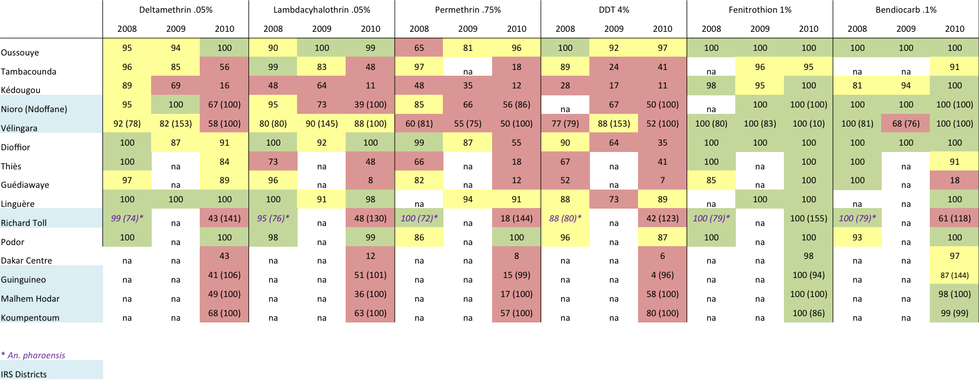

**TANZANIA**

PMI launched IRS on mainland Tanzania in 2007 in Muleba and Karagwe districts in Kagera Region. In 2009, PMI expanded spraying to cover the remaining 5 districts of Kagera Region. In 2010 and 2011, IRS expanded to cover the 6 districts of Mwanza Region and 5 districts of Mara Region for a total of 18 districts. Spraying has been conducted with pyrethroids, but in 2012 carbamates will be used.

Since 2006 Zanzibar has conducted 6 rounds of IRS with pyrethroids. In 2012 carbamates will be used.

**COMMENTS ON DATA:**

Susceptibility data was collected in collaboration with the National Institute for Medical Research, Amani Medical Research Centre and the Zanzibar Malaria Control Program (ZMCP).

**Mainland** – In 2011, WHO tube bioassays were conducted on wild-caught *An. gambiae* s.l. Tests were performed on field-collected adults unless otherwise noted.

423 *Anopheles gambiae* s.l. were analyzed for the presence of the *kdr* mutation. Of these, 115 were *An. gambiae* s.s. and 308 were *An. arabiensis*. None were positive for *kdr*.

**Zanzibar** - WHO tube bioassays were conducted on *An. gambiae* s.l. reared from field-collected larvae. For the 2010 tests on Pemba, 247-431 mosquitoes were tested against each treatment (minimum 13 replicate each) For 2012 tests on Unguja, 100 mosquitoes were tested against each treatment (4 replicates each).

**CONCLUSIONS:**

* For Zanzibar: 1) Mosquitoes on Unguja are susceptible to permethrin, deltamethrin, and bendiocarb with probable resistance emerging toward lambdacyhalothrin; 2) Mosquitoes on Pemba are resistant to pyrethroids; 3) No susceptibility tests for organophosphates have been conducted
* For Mainland Tanzania: 1) *An. gambiae* s.l. populations from Moshi, Muheza, and Arumeru show resistance to pyrethroids. Pyrethroid resistance is also probable in 5 other districts (Babati, Magu, Handeni, Dar e Salaam, Arumeru, & Kilombero); 2) All populations tested are susceptible to carbamates and organophophates; 3) A population with suspected resistance to DDT has been observed in Magu

|  |  |  |  |  |  |  |
| --- | --- | --- | --- | --- | --- | --- |
| Mainland 2011 | DDT 4% | Fenitrothion 1% | Propoxur .1% | Permethrin .75% | Lambda cyhalothrin .05% | Delta methrin .05% |
|
|
| Kilombero | 99 (100) | 100 (123) | 98.8 (80) | 85 (80) | 100 (80) | 96 (80) |
| Kyela | 100 (85) | 98.8 (80) | 98.8 (79) | 100 (86) | 100 (83) | 100 (78) |
| Mvomero | 100 (83) | 100 (81) | 98.8 (80) | 100(82) | 100 (83) | 100 (78) |
| Muheza | 100 (100) | 100 (100) | 100 (100) | 75.3 (95) | 81.8 (95) | 74.5 (95) |
| Lushoto | 100 (100) | 100 (100) | 100 (100) | 100 (100) | 100 (10) | 100 (100) |
| Handeni | 100 (100) | 100 (100) | 100 (100) | 95 (100) | 97.9 (92) | 92.9 (99) |
| Arumeru | 100 (125) | 100 (125) | 100 (125) | 73.6 (125) | 70.4 (125) | 90.4 (125) |
| Dodoma* | 100 (80) | 100 (80) | 100 (80) | 100 (80) | 100 (80) | 100 (80) |
| Tabora | 100 (80) | 100 (80) | 100 (80) | 100 (80) | 100 (80) | 100 (80) |
| Dar es Salaam* | 100 (74) | 100 (60) | 100 (68) | 90.3 (75) | 94.8 (79) | 96.8 (85) |
| Magu* | 80 (20) | 100 (80) | 100 (90) | 100 (100) | 100 (25) | 100 (20) |
| Muleba | 100 (60) | 100 (60) | 100 (80) | 100 (80) | 85 (80) | 85 (80) |
| Babati | 100 (100) | 100 (100) | 100 (125) | 99 (123) | 100 (125) | 96 (125) |
| Moshi | 99.7 (648) | 99.9 (249) | 99.8 (338) | 74 (542) | 54.98 (531) | 71.8 (533) |
| *tests on adults reared from field-collected larvae | | |  |  |  |  |

|  |  |  |  |  |  |  |  |  |
| --- | --- | --- | --- | --- | --- | --- | --- | --- |
|  | Permethrin .75% | | Lambdacyhalothrin .05% | | Deltamethrin .05% | | Bendiocarb .1% | |
| Zanzibar | 2010 | 2011 | 2010 | 2011 | 2010 | 2011 | 2010 | 2011 |
| Unguja | 99 | na | 95 | na | 99 | na | 100 | na |
| Pemba | 50 | na | 49 | 45 (140) | 80 | na | 100 | na |
|  |  |  |  |  |  |  |  |  |
| IRS locations |  |  |  |  |  |  |  |  |

**UGANDA**

PMI is the sole supporter of IRS in Uganda. In 2006, PMI supported a large-scale IRS program in the epidemic-prone southwestern highland district of Kabale. In 2007, PMI targeted its support to high-risk sub-counties of Kabale and extended support to the neighboring district of Kanungu and four northern districts (Kitgum, Pader, Gulu, and Amuru). After consultation with the NMCP, PMI then scaled-back support of IRS in Kabale and Kanungu and prioritized resources on the highest transmission areas of northern Uganda (Kitgum, Pader, Apac, and Oyam). PMI has since concentrated on the northern districts; to date, Kitgum and Pader have received seven rounds of IRS, Amuru and Gulu have received three rounds, and Oyam and Apac have received five rounds of IRS.

IRS was initially conducted with pyrethroids in all districts except Apac and Oyam, which received DDT in 2008. Due to insecticide resistance to both insecticides, a change to carbamates was made in 2010.

**COMMENTS ON DATA:**

Susceptibility data was collected in collaboration with the National Malaria Control Program.

2008: Susceptibility tests were conducted on *An. gambiae* s.l. reared from field-collected larvae.

2009 and 2011: Both *An. gambiae* s.l. reared from field-collected larvae and adult mosquitoes were used.

**CONCLUSIONS:**

* Susceptibility testing has been done in 3 of the 6 PMI supported 2011 IRS districts, the exceptions being Pader, Amuru, and Gulu; however, only Apac and Kitgum have been tested since 2008
* There is resistance to both DDT and pyrethroids in all districts tested
* There is susceptibility to organophosphates in all districts
* Probable resistance to carbamates has appeared in Kanungu and Tororo

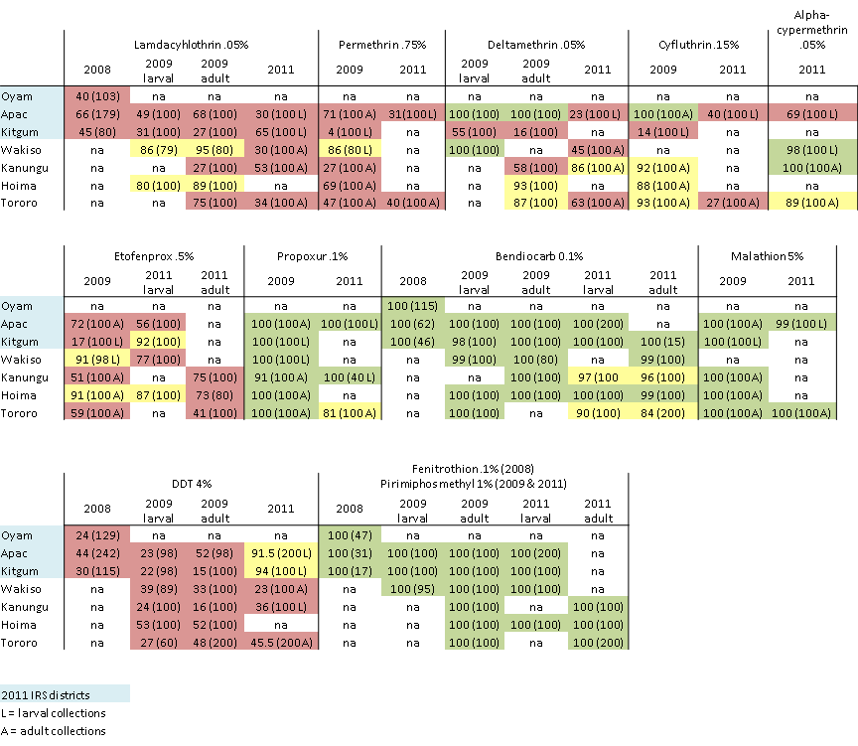

**ZAMBIA**

The government of Zambia began implementing IRS in 2003. In 2007 and 2008, PMI supported IRS was conducted in 15 districts in 5 provinces. In 2009, it was expanded to 36 districts, covering all 9 provinces. In 2010, IRS supported by PMI and other donors sprayed 54 districts nationwide. In the 2011 spray season all 72 districts had IRS activities.

IRS in Zambia was performed using a combination of DDT and pyrethroids until 2011. In 2011, a combination of pyrethroids, carbamates, and organophosphates were used based on local insecticide resistance data (see map below[5]). In 2012 PMI-supported IRS will be conducted using a carbamate and an organophosphate.

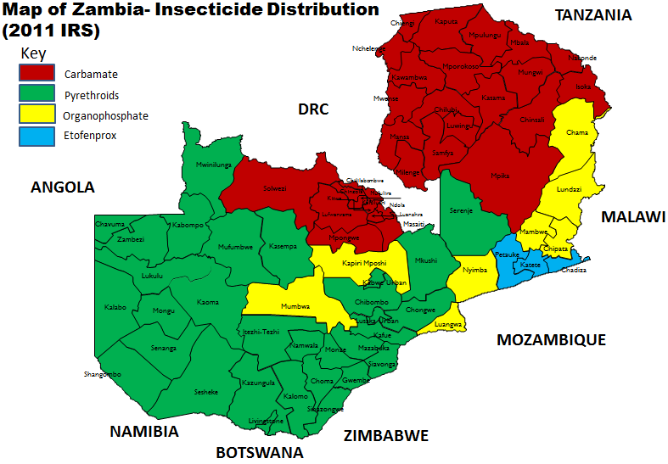

**COMMENTS ON DATA:**

Susceptibility data was collected in collaboration with the Zambia Integrated Systems Strengthening Program (ZISSP) and the National Malaria Control Centre (NMCC).

Overall, *An. gambiae* s.l. from 12 districts were tested and *An. funestus* from 15 districts were tested.

Tested mosquitoes were either reared from field-collected larvae or were offspring of field-collected, blood fed adults. Note that the 2009-11 data have been partially published in Chanda et al. 2011, *PLoS ONE*.

*An. gambiae* s.s. has been shown to carry the kdr-west mutation. Both *An. gambiae* s.s. and *An. funestus* have been tested for metabolic resistance, and both have shown elevated level of p450s.[6]

**CONCLUSIONS:**

* Resistance or probable resistance to pyrethroids has been detected in both *An. gambiae* s.l. (10 districts) and *An. funestus* (12 districts)
* *An. gambiae* s.l. shows resistance to DDT but susceptibility to organophosphates and carbamates
* *An. funestus* in Eastern Province shows carbamate resistance but susceptibility to DDT and organophosphates
* *An. funestus* in other parts of the country remain susceptible to carbamates, DDT, and organophosphates

|  |  |  |  |  |  |  |  |  |  |  |  |  |
| --- | --- | --- | --- | --- | --- | --- | --- | --- | --- | --- | --- | --- |
| ***An. gambiae* s.l.** | | | | | | |  |  |  |  |  |  |
| District (site)  *Sites with kdr-west mutation | Deltamethrin | | DDT | | Permethrin | Etofenprox | | Malathion | | λ-cyhalothrin | | Bendiocarb |
| 2009-11 | 2011-12 | 2009-11 | 2011-12 | 2009-11 | 2009-11 | 2011-12 | 2009-11 | 2011-12 | 2009-11 | 2011-12 | 2011-12 |
| Kapiri Mposhi (Chipepo)* | 42 (43) | na | na | na | na | na | na | na | na | na | na | na |
| Ndola (Chipulukusu)* | 14 (96) | na | 43(428) | na | 29 (41) | 98.4 (43) | na | 100(27) | na | 92 (26) | na | na |
| Luangwa (Chisobe) | 100 (102) | na | na | na | na | na | na | na | na | na | na | na |
| Solwezi (Kizhingezhinge)* | 95 (105) | na | 4 (157) | na | na | na | na | na | na | na | na | na |
| Kabwe (Mukobeko) | 100 (16) | na | na | na | na | na | na | na | na | na | na | na |
| Ndola (Mushili)* | 21 (180) | na | 58 (244) | na | 55 (31) | na | na | 100 (47) | na | na | na | 100 (154) |
| Ndola (Twapia)* | na | na | 67 (135) | na | na | na | na | na | na | na | na | na |
| Mumbwa (Myooye)* | 93 (74) | na | 67 (73) | na | na | na | na | na | na | na | na | na |
| Luangwa (Nyamankalo) | 91 (11) | na | na | na | na | na | na | na | na | na | na | na |
| Luanshya | 49 (85) | 48(25) | 42 (60) | 2 (100) | 68 (40) | 100 (15) | 51 (100) | 100 (27) | na | 72 (105) | 67 (45) | na |
| Kitwe* | 63 (82) | 75 (124) | 22(68) | 2 (100) | 34 (118)^ | 96 (104) | 5 (101)^ | 100 (23) | 100 (387) | 68 (40) | na | 99 (527) |
| Chililabombwe | 72 (65) | na | 44 (25) | 58 (45) | na | 100 (19) | na | 100 (38) | na | 71 (65) | 71 (45) | na |
| Nchelenge | 80 (5) | na | 33 (3) | na | na | na | na | na | na | na | na | na |
| Mufulira | 55 (20) | na | 88 (40) | na | na | na | na | na | na | 30 (20) | na | 99 (117) |
| Masaiti | na | na | na | na | na | na | na | na | na | na | na | 95 (60) |
| Solwezi | na | na | na | na | na | na | na | na | na | na | na | 100 (20) |
| ^ Data from Insecticide Resistance Monitoring Report, prepared by Michael Coleman, LSTM, for ZISSP | | | | | | | | | | | | |
|  | | | | | | | | |  |  |  |  |

|  |  |  |  |  |  |  |  |  |  |  |  |
| --- | --- | --- | --- | --- | --- | --- | --- | --- | --- | --- | --- |
| ***An. funestus* s.l.** | | | | | | |  |  |  |  |  |
| District (site) | Deltamethrin | | DDT | | Permethrin | | Etofenprox | Malathion | | λ-cyhalothrin | Bendiocarb |
| 2009-11 | 2011-12 | 2009-11 | 2011-12 | 2009-11 | 2011-12 | 2009-11 | 2009-11 | 2011-12 | 2009-11 | 2011-12 |
| Chibombo (Chibombo) | 89 (9) | na | na | na | na | na | na | na | na | na | na |
| Chipata | 57 (60) | na | 89 (23) | 100 (20) | na | na | na | na | na | na | 9 (140)^ |
| Luangwa (Chisobe) | 64(50) | na | na | na | na | na | na | 100 (15) | na | 51 (45) | na |
| Chongwe (Kabulongo) | 80 (15) | na | 100 (14) | na | na | na | na | na | na | na | na |
| Kafue | 96 (23) | na | 98 (90) | na | na | na | na | na | na | na | na |
| Luangwa (Manueli) | 73 (11) | na | na | na | na | na | na | na | na | na | na |
| Chongwe (Mufweshya) | 100 (18) | na | 100(21) | na | na | na | na | na | na | na | na |
| Kabwe (Mukobeko) | 96 (26) | na | na | na | na | na | na | na | na | na | na |
| Chibombo (Mulungushi) | na | na | na | na | na | na | na | 100 (7) | na | na | na |
| Mazabuka (Mwanachingwala) | 82 (22) | na | na | na | na | na | na | na | na | na | na |
| Mumbwa (Myooye) | 96 (27) | na | 94 (62) | na | na | na | na | na | na | na | na |
| Mazabuka | 100 (30) | 20 (35) | 100 (10) | na | 91 (11) | na | na | na | na | na | na |
| Luangwa (Nyamankalo) | 81 (87) | na | 88 (33) | na | na | na | na | na | na | na | na |
| Chongwe (Rufunsa) | 67 (66) | na | na | na | na | na | na | na | na | na | na |
| Katete | 59 (143) | 37 (67)^ | 94 (131) | 100 (190) | 60 (20) | 61 (131) | 23 (155) | na | 100 (225) | na | 72 (302) |
| Nchelenge | 94 (82) | na | 97 (87) | na | na | na | na | na | na | na | na |
| Chadiza | na | 30 (37) | na | na | na | na | na | na | na | na | na |
| Kaoma | na | 64 (50) | na | 100 (40) | na | na | na | na | na | na | 98 (45) |
| Senanga | na | na | na | 100 (30) | na | na | na | na | na | na | na |
| Kitwe | na | na | na | na | na | na | na | na | na | na | 99 (80) |
| Solwezi | na | na | na | na | na | na | na | na | na | na | 100 (20) |
| ^ Data from Insecticide Resistance Monitoring Report, prepared by Michael Coleman, LSTM, for ZISSP | | | | | | | | | | | |
|  | | | | | | | | |  |  |  |

**ZIMBABWE**

Currently, the NMCP targets 45 districts in the country for IRS. In 2012 PMI will conduct IRS in 17 districts in 3 provinces (Mashonaland East, Mashonaland West, & Manicaland). From 2009 to 2011, a combination of pyrethroids and DDT has been used for IRS.

**COMMENTS ON DATA:**

Susceptibility data was collected by the National Malaria Control Programme (NMCP) in collaboration with the National Institute of Health Research (NIHR).

WHO tube assays were performed on *An. gambiae* s.l.

**CONCLUSIONS:**

* Despite low numbers of mosquitoes tested in each site (between 20 and 80), 98-100% mortality was recorded for the all insecticides tested for *An. gambiae* s.l. collected from sentinel sites in 8 provinces, suggesting that there is no insecticide resistance according to WHO standards.

|  |  |  |  |  |  |  |  |  |  |
| --- | --- | --- | --- | --- | --- | --- | --- | --- | --- |
| **September 2011 data** | | | | | | | |  | |
| **INSECTICIDE** | | **MASAKADZA (Midlands Province)** | | **KAMHORORO (Midlands Province)** | | **CHILONGA (Masvingo Province)** | | **CHECHECHE (Manicaland Province)** | |
| 4% DDT | | 60/60 (100%) | | 41/41 (100%) | | 37/37 (100%) | | 40/40 (100%) | |
| 0.75% permethrin | | 60/60 (100%) | | 39/39 (100%) | | 40/40 (100%) | | na | |
| 0.15% cyfluthrin | | 60/60 (100%) | | 42/42 (100%) | | 40/40 (100%) | | na | |
| 0.5% etofenprox | | 60/60 (100%) | | 39/39 (100%) | | 39/39 (100%) | | 40/40 (100%) | |
| 0.05% lambda-cyhalothrin | | 60/60 (100%) | | 40/40 (100%) | | 40/40 (100%) | | na | |
| 0.05% deltamethrin | | 60/60 (100%) | | 40/40 (100%) | | 40/40 (100%) | | na | |
| **March-April 2012 data** | | | | | | | | | |  | |
| **Province** | | **District** | | **DDT 4.0%** | | **Bendiocarb 0.1%** | | **Lambdacyhalothrin 0.05%** | | **Malathion 5%** | |
| Mashonaland Central | | Rushinga | | 100 (80) | | 100 (80) | | 100 (80) | | 100 (80) | |
| Centenary | | 100 (40) | | 100 (40) | | 100 (40) | | 100 (40) | |
| Masvingo | | Bikita | | na | | na | | na | | na | |
| Chiredzi | | 100 (40) | | 100 (40) | | 100 (40) | | 100 (40) | |
| Matebeleland South | | Matobo | | na | | na | | na | | na | |
| Beitbridge | | 100 (40) | | 100 (40) | | 100 (40) | | 100 (20) | |
| Matebeleland North | | Lupane | | 100 (20) | | 100 (20) | | 100 (20) | | 100 (20) | |
| Binga | | 100 (20) | | 100 (20) | | 100 (20) | | 100 (20) | |
| Midlands | | Kwekwe | | na | | na | | na | | na | |
| Gokwe South | | 100 (80) | | 100 (80) | | 100 (80) | | 100 (80) | |
| Mashonaland East | | Mudzi | | 100 (80) | | 100 (80) | | 98 (80) | | 100 (80) | |
| Upper Mash Project | | 100 (80) | | 100 (80) | | 98 (80) | | 100 (80) | |
| Mashonaland West | | Hurungwe | | 100 (20) | | 100 (20) | | 100 (20) | | na | |
| Sanyati | | 100 (40) | | 100 (60) | | 98 (60) | | 100 (40) | |
| Manicaland | | Mutasa | | na | | na | | 100 (20) | | na | |

**Acknowledgements**

RTI collected susceptibility data in Angola, Liberia, Mozambique, and Rwanda through 2011. Abt collected data in Uganda and in Angola and Mozambique in 2012.

Additionally, susceptibility data was collected and collated with the help of the following institutions and individuals:

Angola - Dr. Joseph Mwangangi

Benin – Professor Martin Akogbeto (CREC)

Burkina Faso – Dr. Diabate Abdoulaye and Dr. Dabire K. Roch (Centre Muraz)

Ethiopia – Dr. Meshesha Balkew (Addis Ababa University)

Ghana – Professor Daniel Boakye, Dr. Maxwell Appawu, and Dr. Samuel Dadzie (Noguchi)

Kenya – (KEMRI & DOMC)

Madagascar - (IPM & PNLP)

Malawi – Dr. Themba Mzilahowa, PhD (MAC)

Mali – Dr. Mamadou B. Coulibaly (MRTC)

Nigeria – Dr. Georgina S. Mwansat (University of Jos)

Rwanda – (NMCP)

Senegal – Lassana Konate, El Hadji Kaba Sylla, Malick Faye Ndao, Amadou Niang, and Ousmane Faye (UCAD)

Tanzania – William Kisinza (Amani Medical Research Centre); Juma H. Mcha (ZMCP)

Uganda – Michael Okia (NMCP)

Zambia – Emmanuel Chanda (NMCC) and Musapa Mulenga (ZISSP)

Zimbabwe – (NMCP & NIHR)

1. Test procedures for insecticide resistance monitoring in malaria vectors and bioefficacy and persistence of insecticides on treated surfaces (WHO, 1998).
2. Test procedures for insecticide resistance monitoring in malaria vector mosquitoes (WHO, 2012).
3. These districts have been split and now represent 10 districts. PMI support for IRS is targeted to all the districts that are encompassed by the former administrative districts of Rachuonyo, Nyando, and Migori.
4. Some data taken from Abilio 2011, *Malar J*
5. Produced by the Insecticide Resistance and Pesticide Selection Technical Advisory Committee, July 2011.
6. Data from Insecticide Resistance Monitoring Report, prepared by Michael Coleman, LSTM, for ZISSP